# Tableau Health Care Capstone Project

Dashboard 1

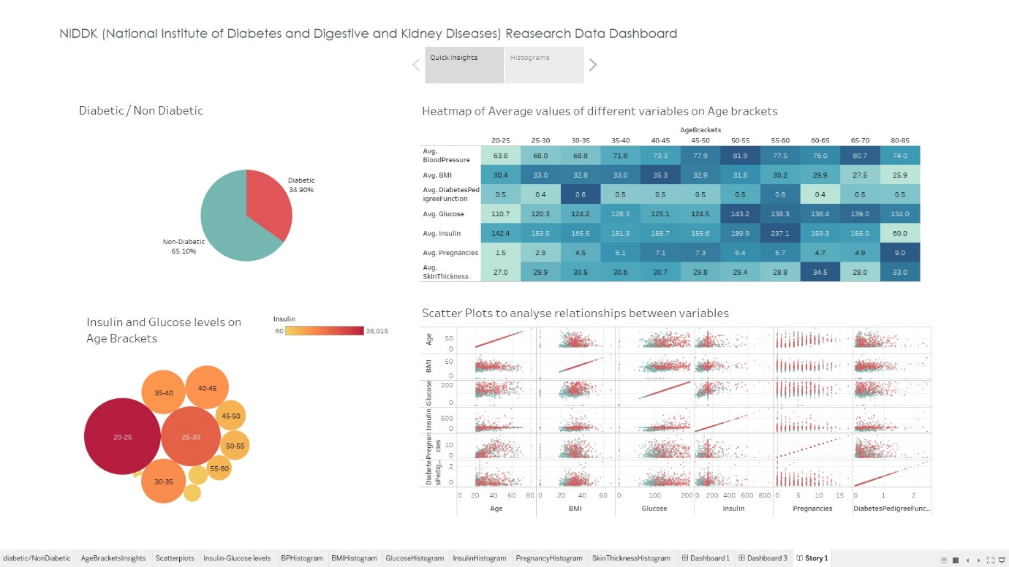

Dashboard 2

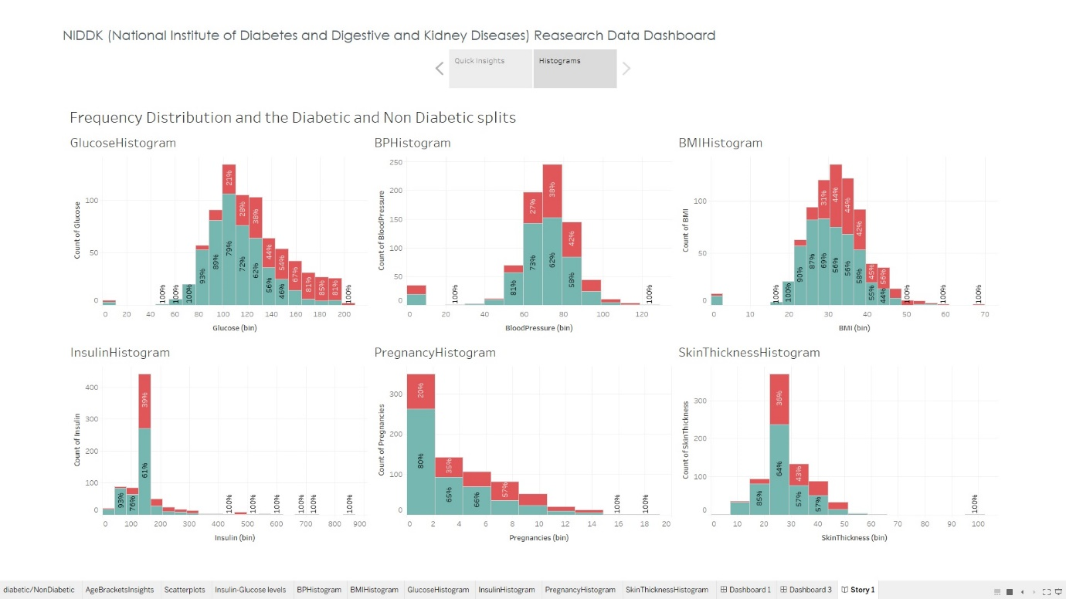

Tableau Public Navigation - <https://public.tableau.com/app/profile/bhavana.jagadish/viz/HealthcareCapstoneProject_16829374308390/DonutPiechart?publish=yes>